Optoelectronics Laboratory -
Transmission 1

David Clarke

B.Eng Electrical & Electronic Engineering

Electrical & Electronic Engineering,
School of Engineering and Applied Science,
Aston University.

11/05/2001

Abstract

In Section 1 a series of experiments will investigate the operation of the two standard transmitter sources employed in optical fibre communications systems; the LASER diode and the light emitting diode (LED). In Section 2 a set of experiments examines a number of properties of the optical fibre link. The responses are described in the latter stages of this report.

Introduction

Optical fibre links now dominate the World’s major trunk communications systems and are penetrating ever deeper into the access and local area networks. Industries operating in these markets require highly skilled scientists, engineers and technicians who can design, install and operate optical communications systems. In order to expedite the development of the necessary hands on practical skills and to experimentally demonstrate basic principles, the objectives of the experiments described here are:

- To characterise all of the major components of a fibre optic telecommunications system (i.e. the transmitter, the fibre and the receiver)
- To build a simple point to point link and
- To experimentally assess the performance of that link including the determination of the upper limits on the link length, bit rate and analogue bandwidth as defined by attenuation and dispersion.

In addition, a number of exercises have been included to ensure a good overall appreciation of the design and performance of state of the art systems relative to the simple system measured here.

Principles of Methods

Attenuation in an optical fibre is measured as the optical power loss in dB at any point along the fibre length relative to the input power. The attenuation of an optical fibre of length, L, is given by

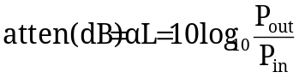

where α is the attenuation coefficient of the fibre (in units of dB/km) and P_{in} and P_{out} are the launched and output power of the link respectively.

In the time domain we can measure the step function response or the impulse response of the fibre. In the step response measurement the optical source is modulated by a square wave with a sharply rising edge and the 10-90% risetime, τ₀, of the transmitter / receiver combination is measured by inspection of the oscilloscope trace of the signal received via a short length of fibre. The measurement is repeated with the fibre reel connecting the transmitter to the receiver to obtain the 10-90% risetime of the entire system – the transmitter, receiver and fibre, τ_{s}. The 10-90% risetime of the fibre, τ_{F}, may then be obtained from the following relationship

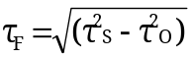

A given length of fibre may be uniquely characterised by measuring either its frequency response, its step response or its impulse response. The impulse response is the derivative of the step response and the frequency response is simply the Fourier transform of the impulse response. On this basis we can derive simple approximate expressions which relate the 3dB bandwidth to the 10-90% risetime, τ_{F}, and the output r.m.s. pulse width, τ_{R}, arising from the launched impulse as follows:

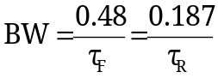

So

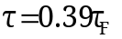

The Bandwidth Length product (BWL) for the fibre is simply BW x L

In digital systems it can be shown that if the r.m.s. widths of Gaussian received pulses exceed 0.25T (where T is the bit period) then the power penalty necessary to maintain a bit error rate of 10⁻⁹ becomes intolerable. This imposes an upper limit on the amount of allowed pulse spreading relative to the bit period and hence an upper limit on the bit rate for a given link length (and vice versa) defined by:

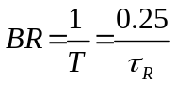

The bit rate distance product is then simply BR x L

Within a step index multimode fibre the principle dispersive mechanisms responsible for pulse broadening are intermodal and material dispersion. The total r.m.s. impulse response of the fibre, τ_{R(tot)}, arising from the combination of material and intermodal dispersion is given by

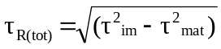

where τ_{mat} and τ_{im} are the r.m.s. impulse responses for material and intermodal dispersion acting separately

Results

SECTION 1

Comparison of LED and Laser Diode Characteristics

- Optical Output Power against Drive Current

LED Characteristics
LED Drive Current (mA) | Receiver Power(μW)
0 | 0
10 | 3.7
20 | 93
30 | 149
40 | 203
50 | 255
60 | 304
70 | 348
80 | 400
Table 1: Optical received power as a function of LED drive current

A plot of these tabulated results is shown in Figure 1.

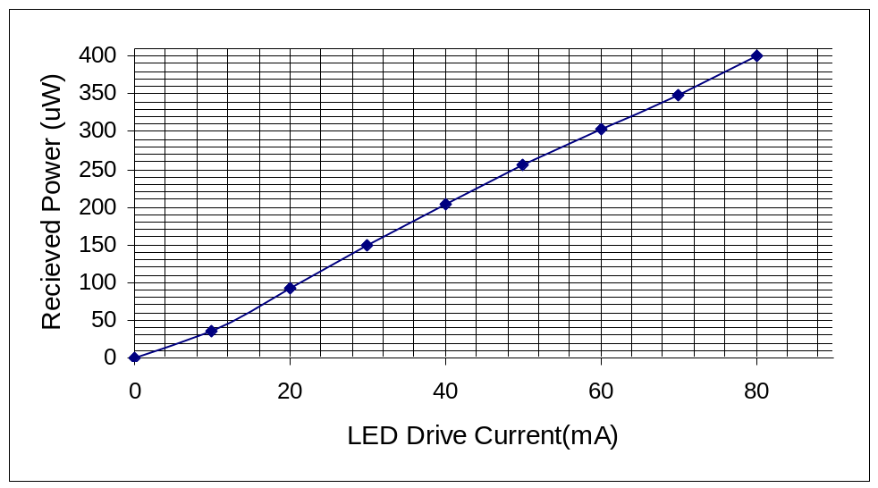
Figure 1: A graph showing the relationship between detected optical power at the receiver as a function of the LED drive current
Taking information directly from Figure 1, the current setting that yields half the maximum output power from the source is:-
The operational position (bias point) for the LED = 38.2mA

LASER Characteristics

LASER Drive Current (mA) | Receiver Power (μW)
0 | 0
10 | 3
20 | 8
30 | 37
40 | 1270
42 | 1550
44 | 1820
Table 2 : Optical received power as a function of LASER drive current

A plot of these tabulated results is shown in Figure 2.
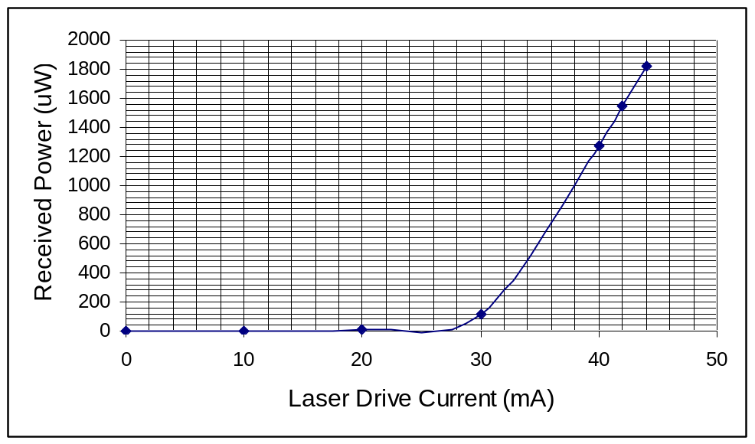
Figure 2: A graph showing the relationship between detected optical power at the receiver as a function of the LASER drive current

Taking information directly from Figure 2
The operational position (bias point) for the LASER = 38mA

SECTION 2

(i) Optical Fibre Connector Loss

LED Characteristics

LED Drive Current (mA) | Received Power (μW)  w/out connector | Received Power (μW)  with connector | Optical Loss
10 | 32 | 25 | 7
20 | 81 | 64 | 14
30 | 130 | 102 | 28
40 | 178 | 140 | 38
50 | 222 | 175 | 47
60 | 266 | 208 | 56
70 | 304 | 238 | 65
79.3 | 338 | 266 | 73
Table 3: Tabulation to determine the optical loss resulting from the use of a fibre connector in the LED system

At the bias point i.e. when the LED drive current equals 38.2mA the overall attenuation experienced from use of the fibre connector is as follows:-

Optical Loss = Power without connector – Power with connector
Optical Loss = 140 x 10⁻⁶ – 102 x 10⁻⁶ = 38μW
Optical Loss(dB) = 10Log(P_{out}/P_{in}) = 10Log(140/102) = 1.37dB

LASER Characteristics

LASER Drive Current (mA) | Received Power (μW)  w/out connector | Received Power (μW)  with connector | Optical Loss
5 | 1 | 1 | 0
10 | 2 | 2 | 0
15 | 4 | 3 | 1
20 | 7 | 5 | 2
25 | 12 | 8 | 4
30 | 30 | 20 | 10
35 | 516 | 360 | 216
40 | 1176 | 810 | 367
44 | 1710 | 1197 | 513
Table 4: Tabulation to determine the optical loss resulting from the use of a fibre connector in the LASER system

At the bias point i.e. when the LASER drive current equals 38 mA the overall attenuation experienced from use of the fibre connector is as follows:-

Optical Loss = Power w/o connector - Power with connector
Optical Loss = 886 x 10⁻⁶ – 616 x 10⁻⁶ = 270μW
Optical Loss(dB) = 10Log(P_{out}/P_{in}) = 10Log(886/616) = 1.57dB

(ii) Attenuation of the Optical Signal over the link Length

LED Characteristics

Bias Current = 38.2 mA,
Received Power = 24μW, 146μW
Optical Loss = 127μW

Total Attenuation with Connector:-

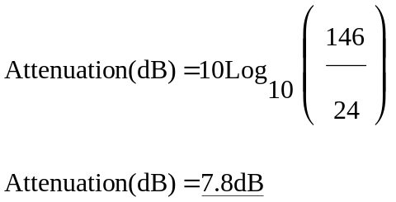

Total Attenuation without Connector:-

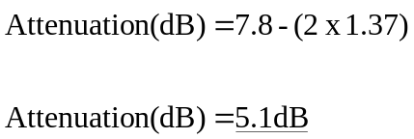 Two connectors each contribute 1.37dB’s of loss

LASER Characteristics

Bias Current = 38 mA,
Received Power = 910μW, 212μW
Optical Loss = 127μW

Total Attenuation with Connector:-

Attenuation(dB) = 10Log₁₀(910/210)
Attenuation(dB) = 6.32dB

Total Attenuation over the link length (without Connector):-

Attenuation(dB) = 6.32 – (2 x 1.57) Two connectors each contribute 1.57dB’s of loss
Attenuation(dB) = 3.18dB

(iii) & (iv)
Answers for these parts of the experiment could not be obtained due to incorrect instructions or faulty equipment. The laboratory staff could not figure out where the problem stemmed.

Main Conclusions

In Section 1 it can be seen from Figure 1 that for an LED source, the received power is proportional to the drive inputted drive current. To make the Laser source operate a high initial input drive current is required to stimulate the photons. Once this threshold drive current has been reached the received power is proportional to the drive current. The Laser source is a much more powerful device than it’s LED cousin, but does require a current above a threshold to allow the laser action commence. For low drive currents, below 28 mA, the LED would be the better choice for transmitting data. The LASER source performs at a much higher level above and beyond 38 mA of drive current. The operational position (bias point) for the LASER and LED are roughly the same, 38 mA and 38.2 mA respectively, this is only coincidence. Over a wider range of drive currents the bias currents would be significantly different.
In Section 2, optical fibre connection loss was looked at. It can be seen that a similar relationship exists between that of LED and LASER diode and optical fibre connector loss. The connector acts a constant loss factor. Looking at Table 3 it can be seen that the optical loss in a LED system is proportional to the drive current. Table 4 shows that in the LASER system there is no optical loss up to a threshold. Then the loss is proportional to drive current, but the rate of change of loss is very high in the LASER system in comparison to the LED system. This same relationship was seen in the comparison of the LED and Laser Diode Characteristics. The optical loss at the bias point was somewhat different for the LASER and LED systems.
A quick comparison of the attenuation of the LED and LASER signals over the link length shows that there is 1.92dB more loss in the transmitted signal from LED in comparison to the transmitted signal from the LASER. The LASER communications system is comparatively a more dominant one than a system with an LED transmitter. The LED may be able to offer signals at low drive currents which the LASER transmitter cannot. It also can offer a mathematically pleasing linear response (great for predicting losses along fibre links).When set to their bias points, the LASER system offers a more powerful alternative. The power received may not be perfectly linear with input drive current, but because the ratio of received power to drive current is much greater than that for the LED and less loss is achieved in an optical fibre link. The LASER source is a much more viable option.

